Assignment - 2
COMPSCI 325 - Fall 2021

Due: September 23rd 11:59 pm.

This assignment consists of 1 part. After finishing the assignment, submit 1 PDF on Gradescope.

Part 1: Designing an accessible stove (50 points)
Imagine that you have been hired by a cooking school. You are tasked with designing a stove to go in a newly renovated kitchen for use with community programs.
In this kitchen, the school will host a range of cooking educational programs targeted at different community groups, including:
- Families cooking with young children,
- New immigrants to the community, and
- Seniors.
Your stove design MUST work for all of these groups.

Design considerations:
A. (10 points) List 5 (total) factors that matter to the community groups. For example, what can each group do or not do? What would they need and want?

B. (6 points) List 3 contexts of use. How will this stove actually be used? Who will use it and under what conditions?

C. (6 points) Rank the design considerations you listed above in terms of importance, then answer: Why did you decide those considerations were the most important?

Review existing designs:
D. (16 points) Look at the following 4 stove designs and identify at least 1 desirable feature and 1 undesirable feature of each. Zoom in to see the text in the images.
 | Desirable features | Undesirable features
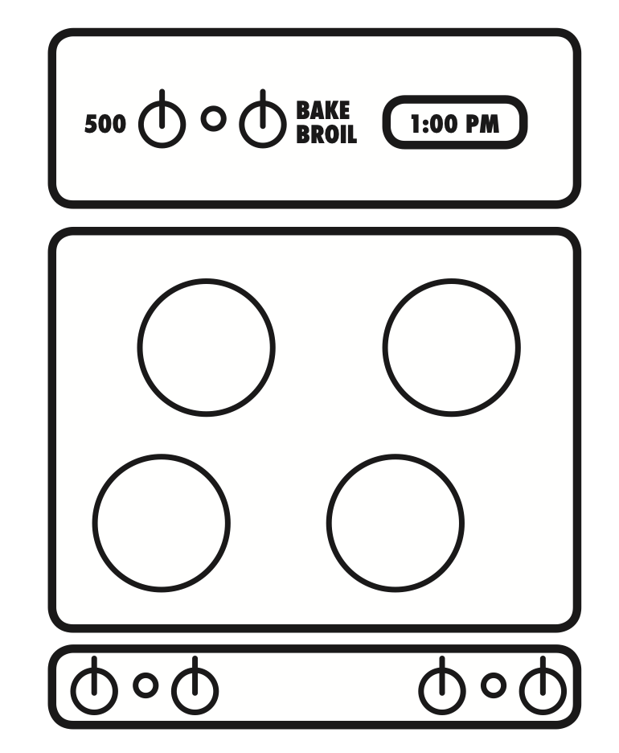
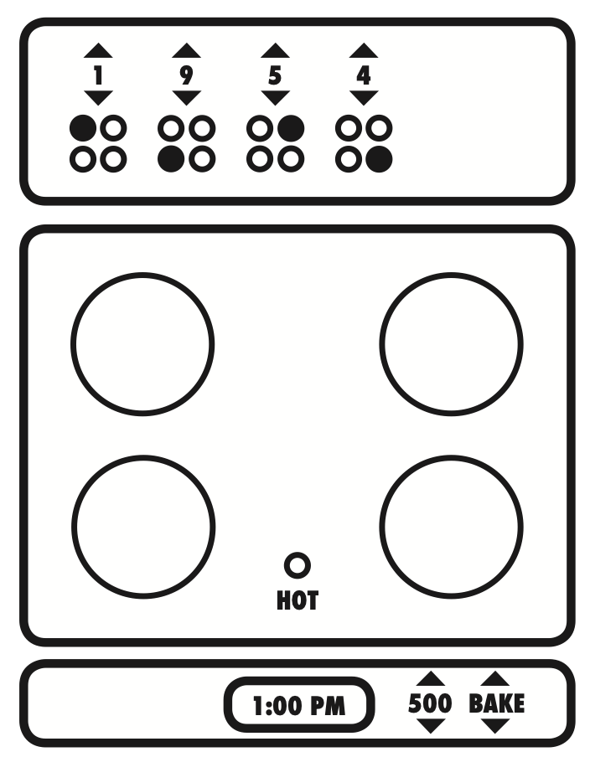
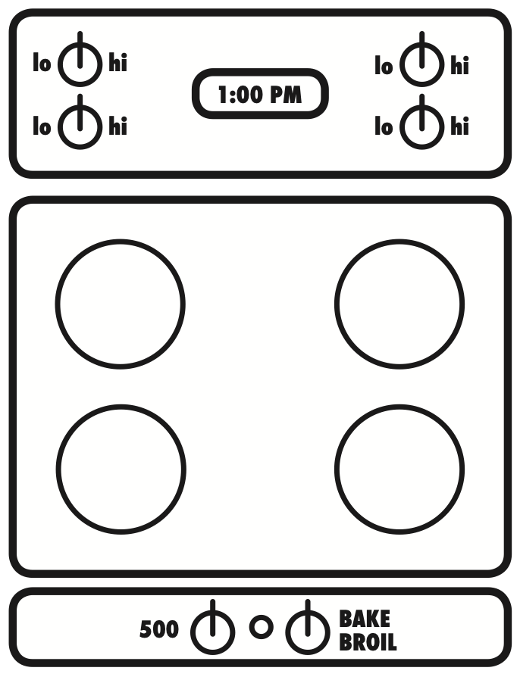
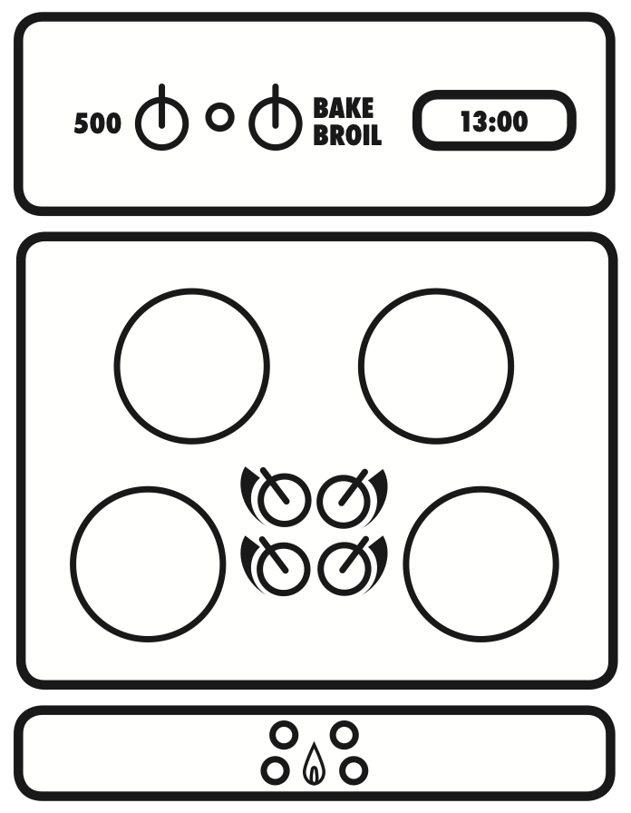

Design your own stove:
E. (6 points) Sketch and label your own design based on the considerations you identified before.

F. (6 points) Justify why your design is the best. Your justification should be in the form of a bulleted list and should argue why your design satisfies the design considerations that you identified in Part A.

