Assignment - 1
COMPSCI 325 - Fall 2021

Due: 09/14/2021 at 11:59 pm.

This assignment consists of 2 parts. After finishing both parts, submit 1 PDF to the assignment on Gradescope.

Part 1: Frustrating interactions (30 points)
1. Think of a technological interaction that frustrated you recently
2. Sketch your experience in any way you like (feel free to add screenshots/pictures):

3. Write or diagram exactly HOW it failed for you. Specify activity, tasks, interactions.

4. Now, dig deeper: write / diagram WHY it failed as best you can. Apply design concepts/considerations/principles.

Part 2: Norman Doors (50 points)
1. For each door, mark down how you think it operates (From Computer Science Unplugged. Bell, Witten and Fellows. 1998)

Push? Yes/No
Pull? Yes/No
Slide it? Yes/No
Interact on the left side? Yes/No
Interact on the right side? Yes/No
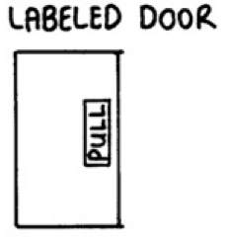 | Push? Yes/No  Pull? Yes/No  Slide it? Yes/No  Interact on the left side? Yes/No  Interact on the right side? Yes/No
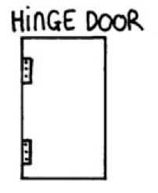 | Push? Yes/No  Pull? Yes/No  Slide it? Yes/No  Interact on the left side? Yes/No  Interact on the right side? Yes/No
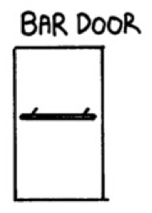 | Push? Yes/No  Pull? Yes/No  Slide it? Yes/No  Interact on the left side? Yes/No  Interact on the right side? Yes/No
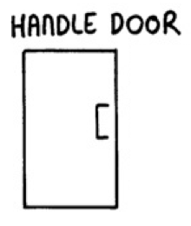 | Push? Yes/No  Pull? Yes/No  Slide it? Yes/No  Interact on the left side? Yes/No  Interact on the right side? Yes/No
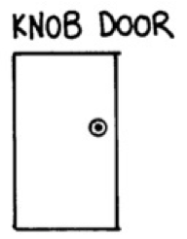 | Push? Yes/No  Pull? Yes/No  Slide it? Yes/No  Interact on the left side? Yes/No  Interact on the right side? Yes/No
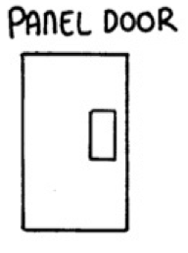 | Push? Yes/No  Pull? Yes/No  Slide it? Yes/No  Interact on the left side? Yes/No  Interact on the right side? Yes/No
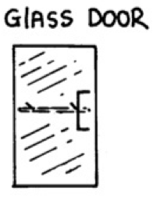 | Push? Yes/No  Pull? Yes/No  Slide it? Yes/No  Interact on the left side? Yes/No  Interact on the right side? Yes/No

2. For each door, identify which design concept(s) are most relevant to how well a user could operate that door (e.g. affordance, signifier, mapping, visibility, constraints, feedback, transfer effects).

3. Which door do you think is the most usable? Briefly explain your reasoning.

